Lab 6.5: Docker Compose with Centos

This section will show you how to use Docker Compose to manage a container.

This lab has 3 sub-sections:

6.5.1: Build a Dockerfile

6.5.2: Create a docker-compose.yml file

6.5.3: Start the server and exit the container once you have successfully signed in

**Step 6.5.1:** Build a Dockerfile.

Download the docker-compose executable.

*cd  
mkdir bin  
curl -L "https://github.com/docker/compose/releases/download/1.9.0/docker-compose-$(uname -s)-$(uname -m)" -o bin/docker-compose  
chmod +x bin/docker-compose*

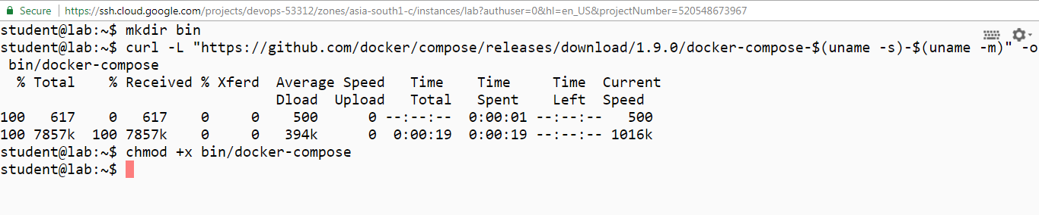

Create a Dockerfile.

*touch Dockerfile*

*vi Dockerfile*

Add the content mentioned below in the Dockerfile.

FROM centos:latest

RUN yum install -y openssh-server

RUN mkdir /var/run/sshd

RUN useradd -c “Student User” -m student

RUN echo “student:student” | chpasswd

RUN ssh-keygen -t rsa -f /etc/ssh/ssh_host_rsa_key -q -N “”

EXPOSE 22

CMD [“/usr/sbin/sshd”,”-D”]

Build the Docker image.

*docker build -t centos-sshd .*

After executing the command above, you should get the result “Successfully built” as shown below.

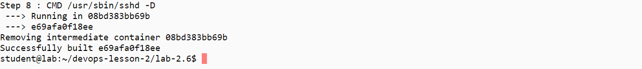

Run the image.

*docker run -d --name sshd -p 2020:22 centos-sshd  
docker ps*

Connect to the ssh server.

*ssh -p 2020 student@localhost*

Answer **yes** to accept the RSA key.

Give the password *student*.  
Verify that you are logged into the server.  
Log out with CTRL+D.

Stop the server.  
*docker rm -f sshd*

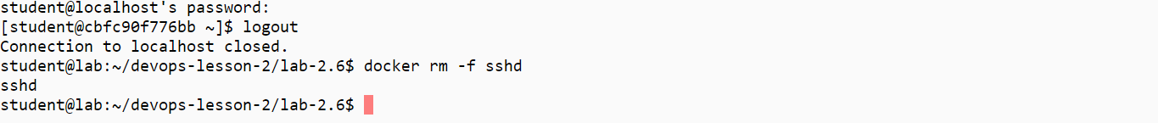

**Step 6.5.2:** Create a docker-compose.yml file.

touch docker-compose.yml

vi docker-compose.yml

Add the content mentioned below in the docker-compose.yml file.

version: “2”

services:

sshd:

build: sshd

image: centos-sshd:latest

ports:

-“2020:22”

Look at the Docker Compose YAML file.

*cat docker-compose.yml*

**Step 6.5.3:** Start the server and exit the container once you have successfully signed in.

The directory **sshd** is a build directory containing a copy of the Dockerfile.  
Start the server.

*~/bin/docker-compose up -d  
~/bin/docker-compose ps*

Connect to the ssh server.

*ssh -p 2020 student@localhost*

Give the password**student**.

Verify that you are logged into the server.  
Log out with CTRL+D.

Stop the server.

*~/bin/docker-compose down  
~/bin/docker-compose ps*